

**Coffee Shop Application**

Mobile Application Development

(Group 326)

420-C04-MT MOBILE PROGRAMMING FOR ANDROID

**Submitted By: Submitted To:**

Adnanuddin Khaja (2094115) Prof. Vijay Beney Krupal Kalangi

Prabhjeet Kaur (2093731)

Yuvraj Sharma (2096337)

Gurwinder Singh Sandhu (2092982)

**Table of Contents**

Introduction.............................................................................................3

Scope...................................................................................................... 3

Functional requirements ........................................................................ 4

Hardware & Software Requirements…………………………………...4

Activity Diagram .....................................................................................5

Use Case Diagram………………………………………………………6

Class diagram ..........................................................................................7

Sequence Diagram……............................................................................8

GitHub and Database…………………………………………………….9

Screen Flow…………………………………………………………….10

**Introduction:**

The Coffeeshop application is a Java-based application which is used to order coffee and some cookies for users. User needs to create profile in order to use the application which contains flyers, featured beverages and categories for coffee and snacks. The user can choose the product of his choice and see a description of any item. In the description section users can also choose the size of and quantity of the item. There is also the option for the users to choose the option from delivery or the pickup as per their convenience.

**Scope:**

The main goal of our application is to assist those who are busy with their lives and are always in a rush to get breakfast. Our software makes it possible for them to have coffee and cookies for breakfast. Moreover, by using our app, they can order coffee and some snacks for delivery while they are at work or at home. The work for this project is equally divided between the team. We have discussed where to start and where to improve.

**Functional Requirements:**

* Dashboard
* Sign In with Google
* Sign in with Facebook
* Signup
* Forget password
* Categories
* Product list
* Product description
* Cart shipping
* Checkout
* Order list
* Database connectivity
* Notification
* Communication

**Hardware & Software Requirements:**

* System: 1GHz or faster 32-bit(x86) or 64-bit (x64) processor
* RAM: 1GB or above.
* Hard Disk: 16GB available disk space.
* Operating System: Windows 7 & or above. (32or 64-bit mode)
* Android Studio
* Java Development Kit (JDK)

**Activity Diagram:**

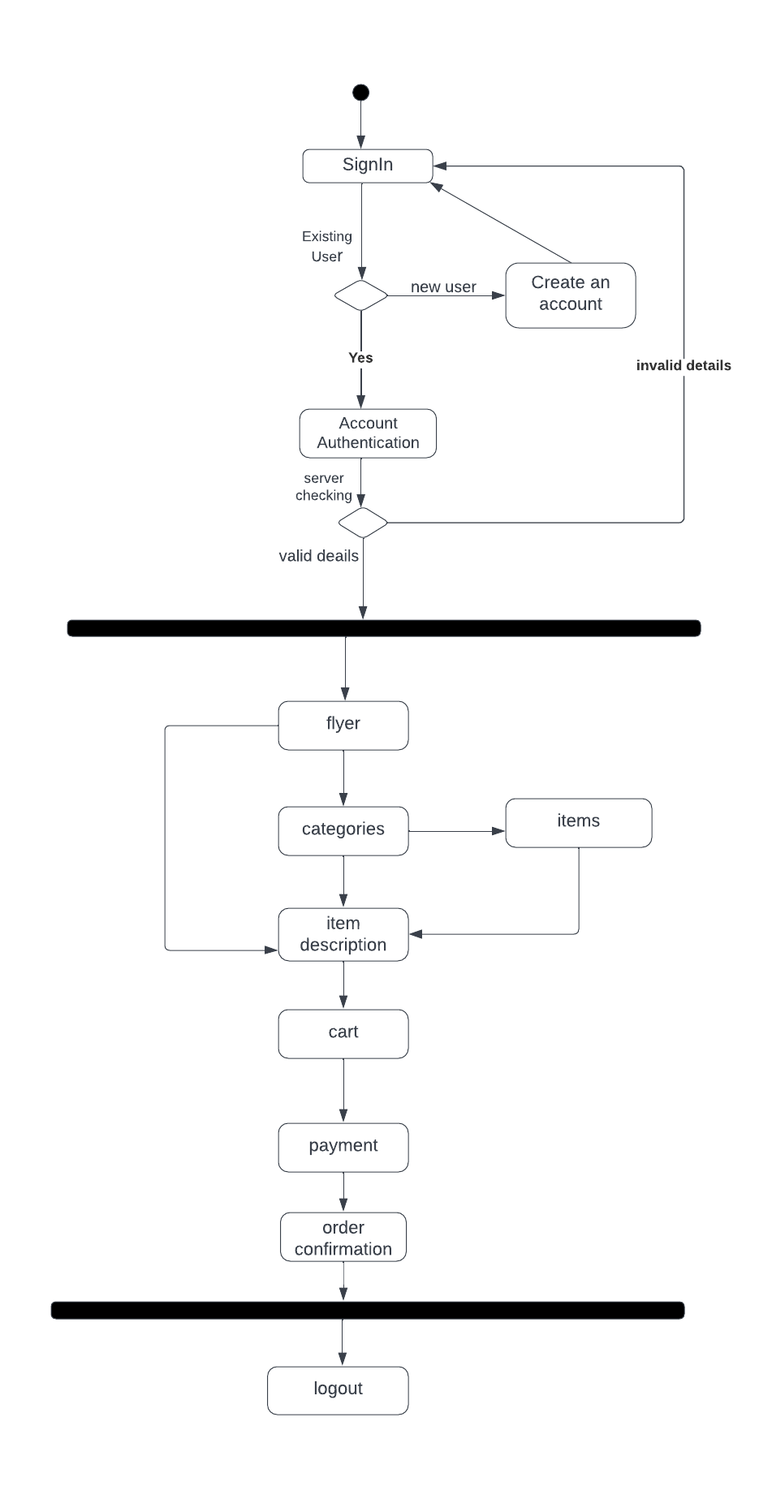

**Use case:**

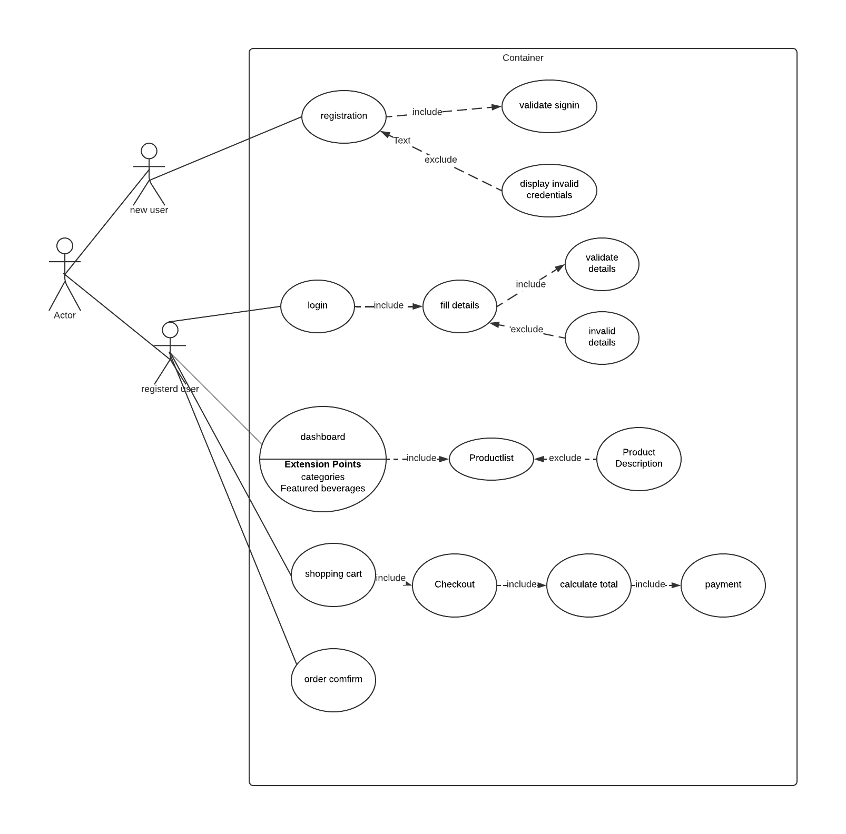

**Class diagram:**

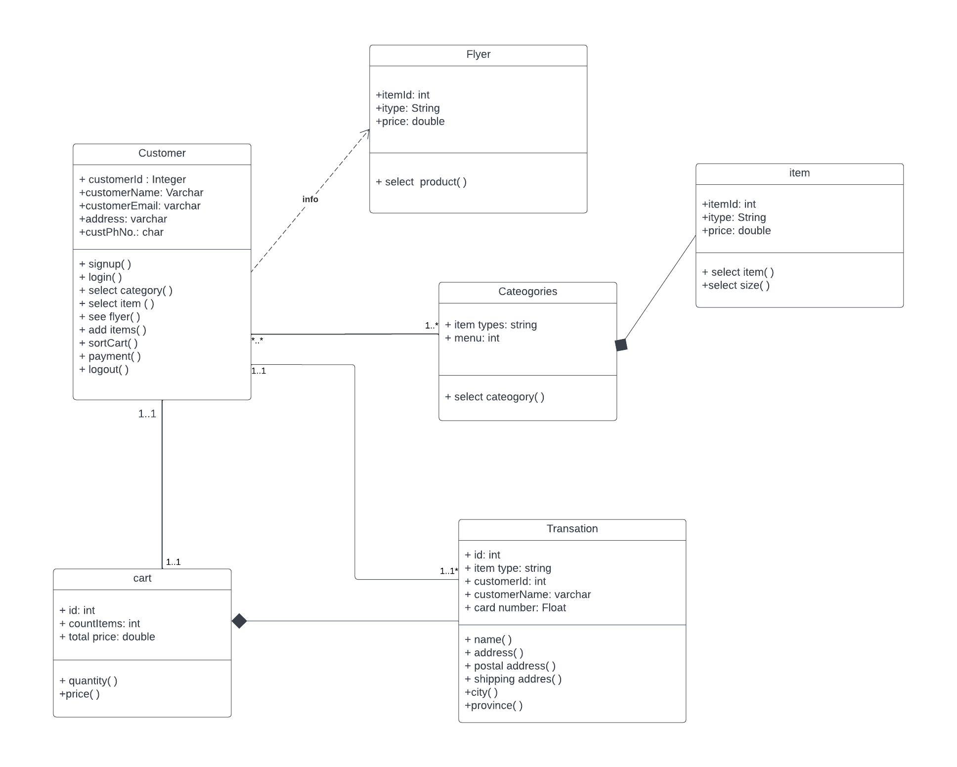

**Sequence Diagram:**

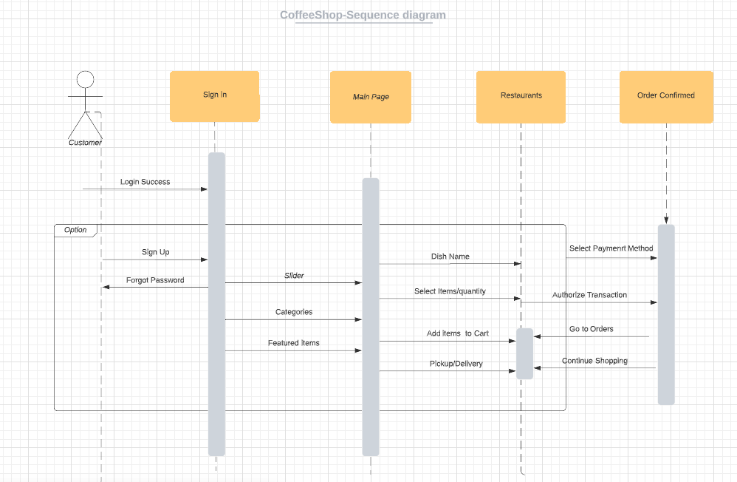

**GitHub Link:**

<https://github.com/aklavyaa/CoffeeShop.git>

**Database (Firebase) URL:**

<https://console.firebase.google.com/project/coffeeshopapp-f1204/overview>

**Screen Flow:**

